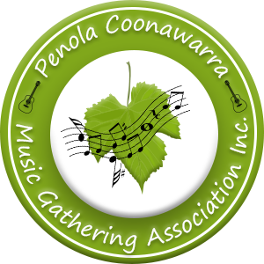

The Penola Coonawarra Acoustic Music Gathering March 1st-3rd is a fun 3- day feast of great music with an emphasis on original music. It will be held in the McCorquindale Sports Centre on the weekend before the long weekend in March 2025, before Port Fairy and Sanford Music Festivals. Camping is available from Wednesday 26th February – 5th March with plenty of things to do in the Penola Coonawarra region.

Important notes for performers
Paid performers must have their own public liability insurance and will be required to provide a copy of their Certificate of Currency. When performing, you are a Gathering service provider and as such are not covered by the Gathering's public liability insurance. We suggest investigating insurance options with Folk Alliance Australia - see www.folkalliance.org.au . You need to be or become a member of Folk Alliance Australia to take advantage of this insurance.
Alternatively, you may wish to donate your performance to the Gathering, in which case you would be considered a volunteer and be covered by the Gathering's public liability insurance.
Performers must also accept all responsibility for their tax obligations, superannuation and Work Cover requirements.
All fees quoted are to be totally inclusive of all costs such as GST, travel, etc.
- We do not supply free tickets for performers partners, family members, managers or entourages.
- All performers must be double vaccinated and provide proof on arrival.

Our criteria for selection.

- we will be trying not to double up with the same artists as Sandford, although they are welcome to come and join in jam sessions etc.
- we will only be inviting 20% of artists back the following year and
- every act must have at least 20-30% of original music.

Penola Coonawarra Acoustic Music Gathering
March 1-3rd 2025
Expression of Interest in Performing
Please complete form and return by email to pcmusicgathering@gmail.com

Act/Band/Performer Name:
Genre:

Description:

Workshop:

Band Members Names | Instruments Played
Contact Person: | Contact Phone: | State

Email Address:

Website:

Facebook:

Youtube:

Requested Fee GST Inclusive | Do you have merchandise for commission free sales. Y/N

Accommodation:
Free campsites are readily available for performers
Other accommodation is limited and may be by billet with local families.
Accommodation Requirements: | Dietary Requirements

Insurance Cover

Our main stage program usually allows 45 minutes including changeovers.
Other stages & venues may differ.
When would you be available to perform? (Multiples ok)
- Friday Evening Sunday Morning
- Saturday Morning Sunday Afternoon
- Saturday Afternoon Sunday Evening
- Saturday Evening

